**Eric Stock Casino Blackjack**

**CP1935: Systems Analysis**

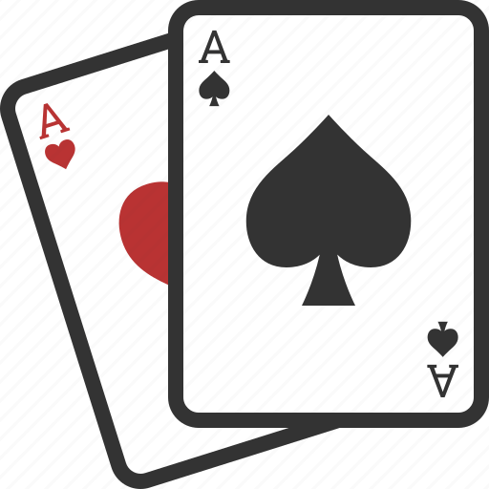

**Group Members:**

Nathan Atkins

Nicholas Baker

Riley Burke

Daniel Rowe

**Date: November 29th, 2021**

Contents

Executive Summary 2

System Request 3

Requirements Definition 4

Functional Requirements 4

Controls 4

Gameplay 4

Non-Functional Requirements 4

Cultural & Political 4

Operational 4

Performance 4

Securiity 5

Functional Models 5

Use Case Diagram 5

Activity Diagram 6

Structural Models 7

CRC Cards 7

Class Diagram 7

Behavioral Models 8

Sequence Diagram 8

Behavioral State Machine 8

# Executive Summary

# System Request

**Project:** Blackjack program

**Client:** Eric Stock

**Project Sponsor:** The project sponsor is Eric Stock

**Business Need**

The client wishes to have a prototype blackjack game created.

**Business Value**

The client is considering adding a web interface around the game and releasing it to help advertise their casino.

**Special Issues or Constraints**

The following issues need to be considered: system needs to be finished by December 10th, 2021.

# Requirements Definition

## Functional Requirements

### Controls

All commands are typed due to the program being a text based program.

* Type “Play” to start the game.
* Type “Check balance” to check your balance.
* Type “Add funds” to add funds to the game.
* Type “Exit” to stop playing the game.
* Enter 1-5 for number of players.
* Type your bet amount.
* Type “Hit” to draw another card.
* Type “Stand” to stop drawing cards.

### Gameplay

* Each player attempts to beat the dealer by drawing cards until they are close to 21 or at 21 without going over. A total of 21 is called blackjack.
* The game uses a standard deck of 52 cards.
* The cards with numbers on them are equal to the numbers on them.
* The ace is worth 1 or 11
* Face cards are worth 10.
* Before the deal begins, each player places their bets with the min being $5 and the max being $1000.
* Blackjack rewards 3:2 payout, otherwise 1:1.
* The cards will be shuffled after each hand.
* The dealer will have unlimited money.
* The dealer’s winnings and losses will be stored into an external file.

## Non-Functional Requirements

### Cultural & Political

* The primary focus of the game is to have fun by trying to win against the dealer.

### Operational

* The game will require Windows 7 or higher.
* The game will require a minimum of 2 GB of ram.
* The game will open with the command window.
* The game will require python to be installed to run.

### Performance

* The game will run without crashing.

### Securiity

* No security requirements are anticipated.

# Functional Models

## Use Case Diagram

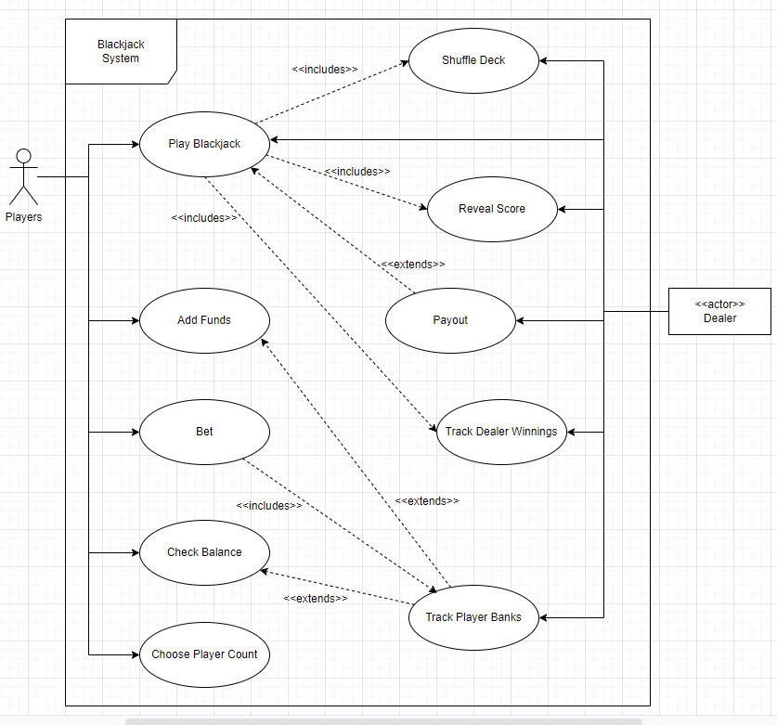

## Activity Diagram

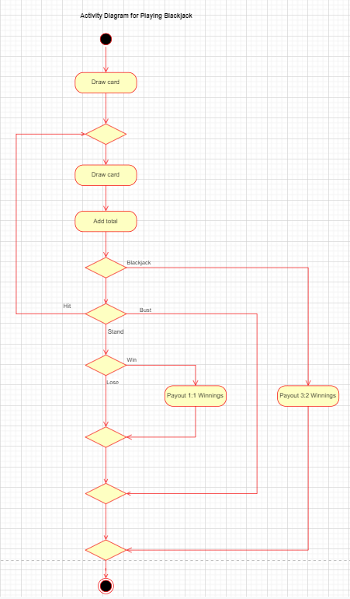

# Structural Models

## CRC Cards

## Class Diagram

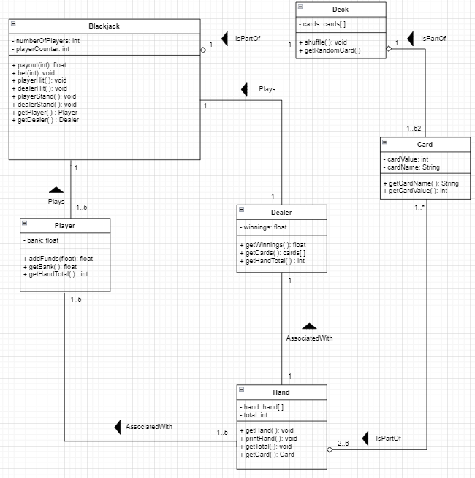

# Behavioral Models

## Sequence Diagram

## Behavioral State Machine